CD LAB
Chinmayee Parida
180905055
CSE-B
V-SEM

RECURSIVE DESCENT PARSER (LAB-6)
Date- 10.12.20

C program that -

Q1. S→a | > | ( T )
T→T, S|S

CODE

#include <stdio.h>
#include <stdlib.h>
#include <string.h>

int curr = 0;
char str[100];

void S();
void T();
void Tprime();

void invalid()
{
printf("***ERROR***\n");
exit(0);
}
void valid()
{
printf("***SUCCESS***\n");
exit(0);
}

void S()
{
if (str[curr]== 'a')
{
curr++;
return;
}
else if (str[curr]=='>')
{
curr++;
return;
}
else if ( str[curr]=='(')
{
curr++;
T();
if(str[curr]==')')
{
curr++;
return;
}
else
invalid();
}
else
invalid();

}

void T()
{
S();
Tprime();
}

void Tprime()
{
if (str[curr]== ',')
{
curr++;
S();
Tprime();
return;
}
}

int main()
{
printf("Enter String:");
scanf("%s", str);
S();
if(str[curr]=='$')
valid();
else
invalid();
}

OUTPUT

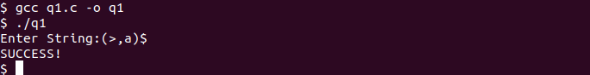

Q2. S→UVW
U →(S) | aSb | d
V → aV | ε
W → cW | ε

CODE

#include <stdio.h>
#include <stdlib.h>
#include <string.h>

int curr = 0;
char str[100];

void S();
void U();
void V();
void W();

void invalid()
{
printf("***ERROR***\n");
exit(0);
}
void valid()
{
printf("***SUCCESS***\n");
exit(0);
}

void S()
{
U();
V();
W();
}
void U()
{
if ( str[curr]=='(')
{
curr++;
S();
if(str[curr]==')')
{
curr++;
return;
}
else
invalid();
}
else if ( str[curr]=='a')
{
curr++;
S();
if(str[curr]=='b')
{
curr++;
return;
}
else
invalid();
}
else if ( str[curr]=='d')
{
curr++;
return;
}
else
invalid();
}

void V()
{
if ( str[curr]=='a')
{
curr++;
V();
return;
}

}

void W()
{
if ( str[curr]=='c')
{
curr++;
W();
return;
}

}

int main()
{
printf("Enter String:");
scanf("%s", str);
S();
if(str[curr]=='$')
valid();
else
invalid();
}

OUTPUT

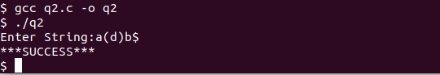

Q3. S→aAcBe
A→Ab|b
B→d

CODE

#include <stdio.h>
#include <stdlib.h>
#include <string.h>

int curr = 0;
char str[100];

void S();
void A();
void Aprime();
void B();

void invalid()
{
printf("***ERROR***\n");
exit(0);
}
void valid()
{
printf("***SUCCESS***\n");
exit(0);
}

void S()
{
if (str[curr]=='a')
{
curr++;
A();
if (str[curr]=='c')
{
curr++;
B();
if (str[curr]=='e')
{
curr++;
return;
}
}

}
else
invalid();
}

void A()
{
if (str[curr]=='b')
{
curr++;
Aprime();
return;
}
}

void Aprime()
{
if (str[curr]=='b')
{
curr++;
Aprime();
return;
}
}

void B()
{
if (str[curr]=='d')
{
curr++;
return;
}
}

int main()
{
printf("Enter String:");
scanf("%s", str);
S();
if(str[curr]=='$')
valid();
else
invalid();
}

OUTPUT

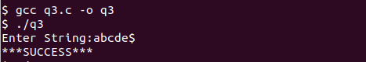

Q4. S →(L) | a
L → L,S | S

CODE

#include <stdio.h>
#include <stdlib.h>
#include <string.h>

int curr = 0;
char str[100];

void S();
void L();
void Lprime();

void invalid()
{
printf("***ERROR***\n");
exit(0);
}
void valid()
{
printf("***SUCCESS***\n");
exit(0);
}

void S()
{
if ( str[curr]=='(')
{
curr++;
L();
if(str[curr]==')')
{
curr++;
return;
}
else
invalid();
}
else if (str[curr]=='a')
{
curr++;
return;
}
else
invalid();
}

void L()
{
S();
Lprime();
}

void Lprime()
{
if (str[curr]== ',')
{
curr++;
S();
Lprime();
return;
}
}

int main()
{
printf("Enter String:");
scanf("%s", str);
S();
if(str[curr]=='$')
valid();
else
invalid();
}

OUTPUT
